~A000-Asia-China-Liangzhu-Disk of Heaven-Shaman-Feather Headdress-Taotie-Raptors-Early Liangzhu Period-3400-3000 BCE

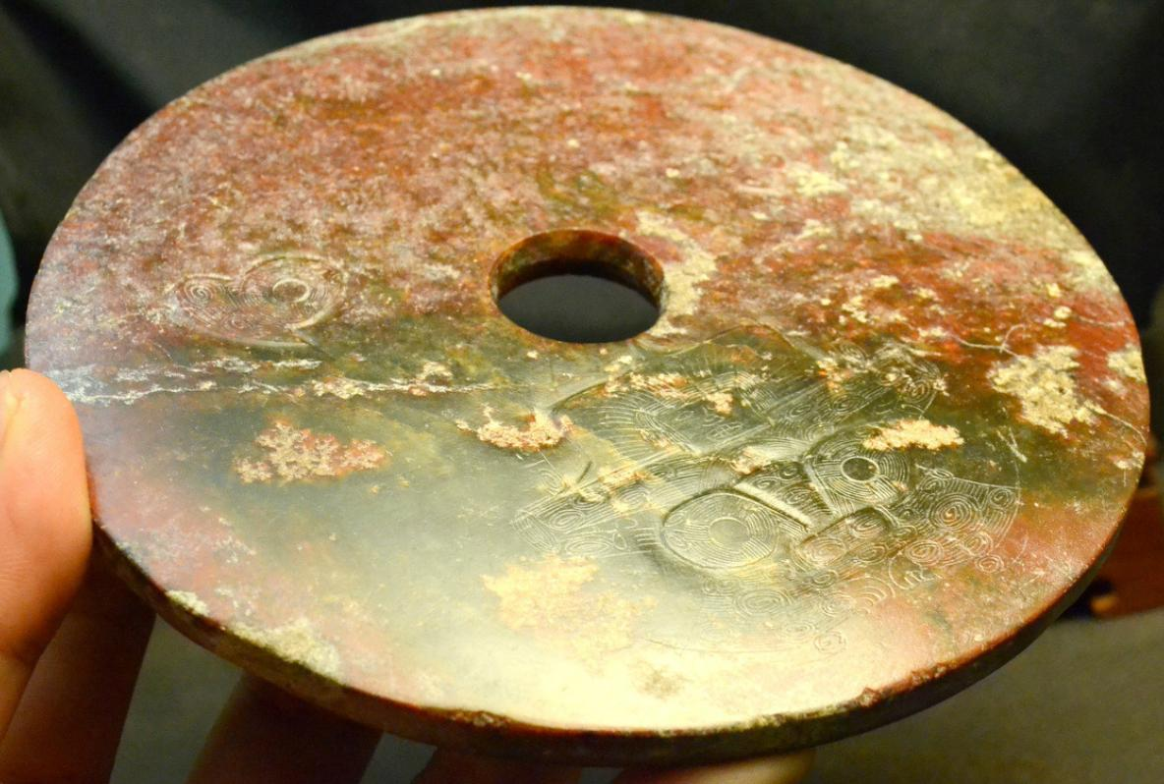

Fig. 1. China-Liangzhu-Disk of Heaven-Shaman-Feather Headdress-Taotie-Raptors-Early Liangzhu Period-3400-3000 BCE

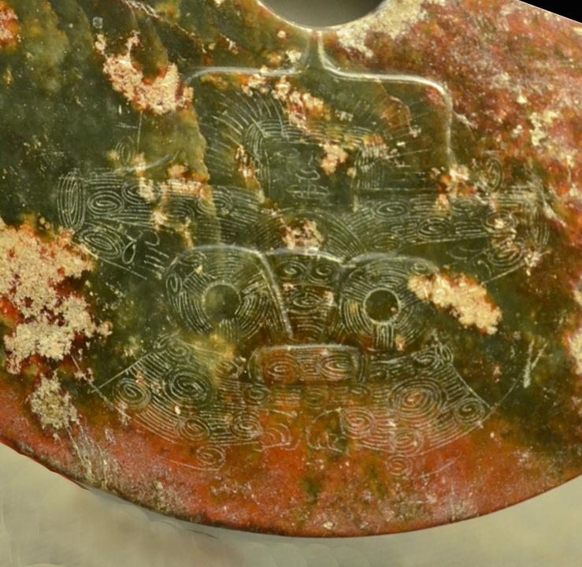

Fig. 2. Detail. China-Liangzhu-Disk of Heaven-Shaman-Feather Headdress-Taotie-Raptors-Early Liangzhu Period-3400-3000 BCE-- a shaman with a feathered headdress surmounting a “taotie” or bilaterally symmetrical, symbolic zoomorph in the shape of a wild boar. On the outer rim of the disc are two images of raptors (birds with down-curved beaks) that are the spirit helpers of the shaman in his ascent to the heavens, which are symbolized by the circularity of the *Bi*-disc. A very similar design is found on Liangzhu *congs*.

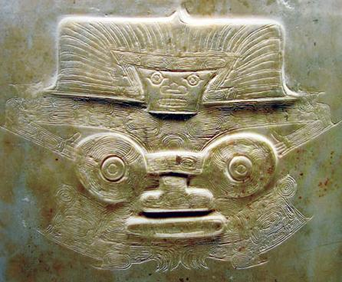

Fig. 3. Shaman with feather headdress surmounting a Taotie on a *cong* from tomb M12, Fanshan, Yuhang County, Zhejiang Province, now in the Zhejiang Province Museum (from Zhejian Province Museum. See also Chang et al. 2005. fig. 4.45, p. 112.

`Jade discs used in worship in the early Neolithic period do not represent spiritual beings in either human or animal shape that were believed to animate nature but were the objects themselves at a time when the concept of the spirit of a thing was not yet separated from the thing itself. In this context this disc is a true effigy, an engraved bas-relief image of a Taotie or Animal Deity, the image of a ruling animal ancestor according honor to the Sun in its various seasonal manifestations as it affected animals. In fact, this jade corresponds to one of the oldest forms of the Chinese graph designating the Sun disc 太阳盘.

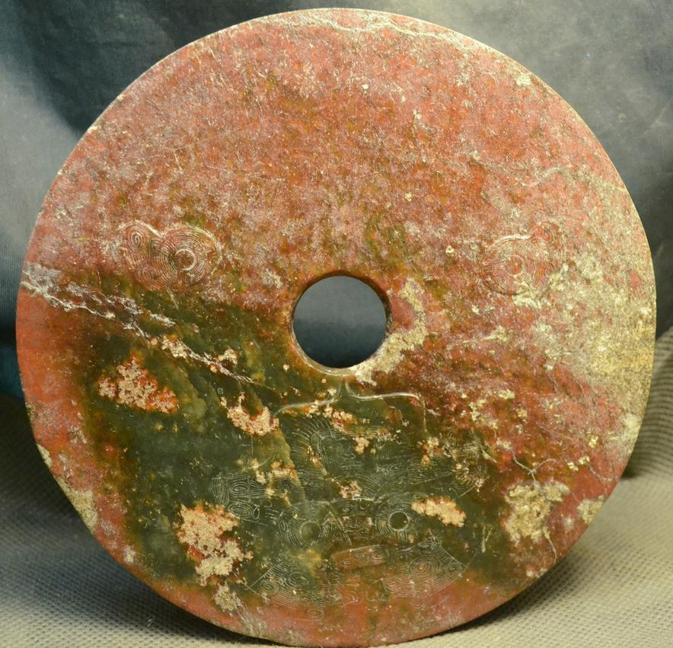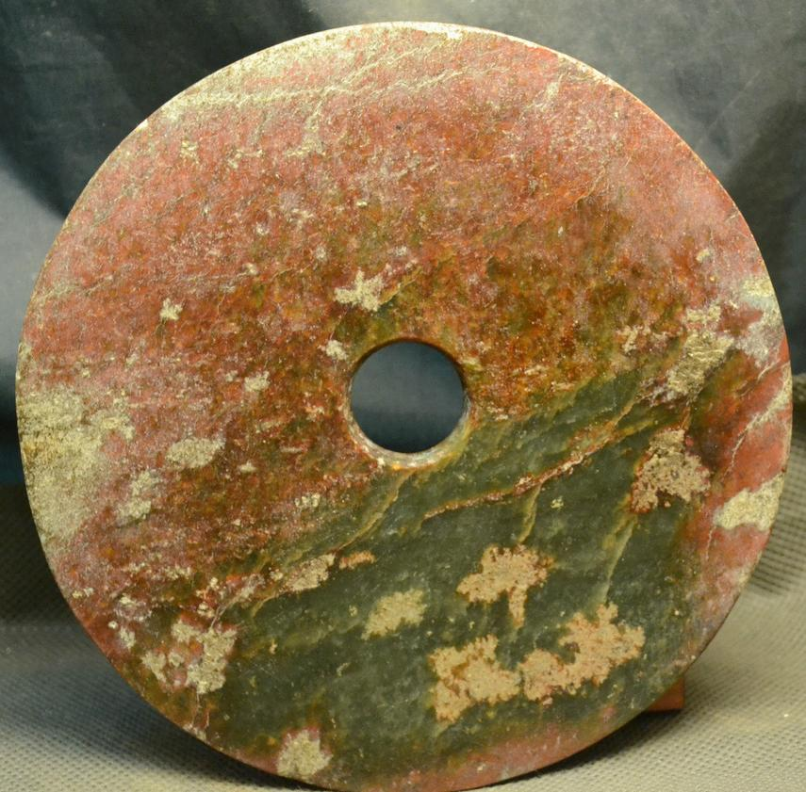

Fig. 4-5. Reverse and Obverse. China-Liangzhu-Disk of Heaven-Shaman-Feather Headdress-Taotie-Raptors-Early Liangzhu Period-3400-3000 BCE Showing the three cartouche-like panels representing an anthropomorphic shamanic mask suggesting the meditation on this disk would induce a shamanic trance. The residual green is probably from hematic fluids of the deceased and is clearly observable in this photo.

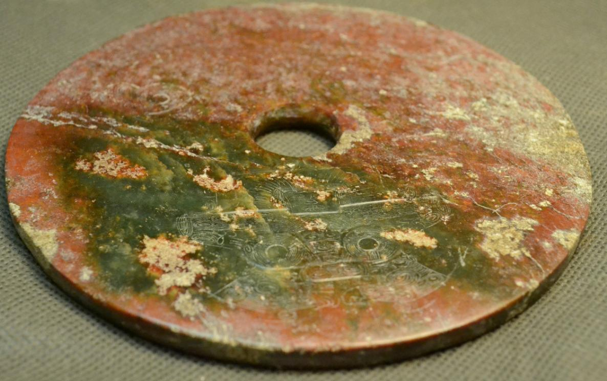

Fig.6. Reverse. China-Liangzhu-Disk of Heaven-Shaman-Feather Headdress-Taotie-Raptors-Early Liangzhu Period-3400-3000 BCE.

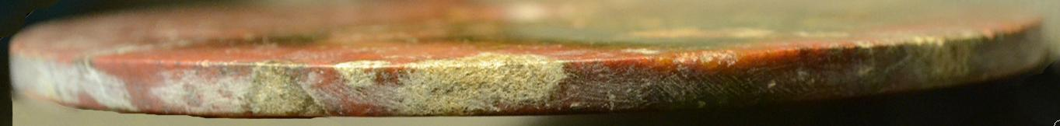

Fig. 7. Edge-on view. China-Liangzhu-Disk of Heaven-Shaman-Feather Headdress-Taotie-Raptors-Early Liangzhu Period-3400-3000 BCE.

**Case no.: 5**

**Accession Number:**

**Formal Label:** Liangzhu-Jade Sun Disk-Taotie-Raptors-良渚 - 玉太陽盤 - 猛-ca 3200 BCE

**Display Description:** This Liangzhu-Jade Shamanic disc has images of a Taotie and two Raptors (良渚 - 玉太陽盤 - 猛). This disc is of an anthropomorphic Master of Animals wearing a feather headdress and leaning with arms and fingers outstretched above a Liangzhu taotie, a bi-laterally symmetrical zoomorphic wild boar mask. The taotie has two circular eyes and a lozenge–shaped mouth. This iconography undoubtedly harkens back to the Paleolithic Period when shamanic imagery characterized the symbolism of hunter-gatherers and was the imagery on petroglyph panels. Indeed, Hayashi Minao argues that the anthropomorphic figure surmounting the taotie on congs derives from “zhu/chu” meaning “master” (Hayashi 1990:6).

The residual green color of the Bi PI Disc suggests the color symbolism of Heaven. In fact, this Bi PI Disc was probably totally green, and its present reddish color is thought to have been produced by minerals leaching from hematic fluids into the nephrite during burial, a process that occurs in the first weeks after interment.

The late Zhou ritual classic, *Zhou Li* p, *Chou Li*  wg(周禮) in the middle of the 2nd century BCE, compiled some three thousand years after the present example was manufactured, stipulated that "jade is used to make the six instruments by which the king worships Heaven and Earth and the four quarters [Spring, Summer, Autumn, Winter]. By the green *bi* (p), *pi* (wg) [round jade disk], heaven is worshipped … " (Biot 1851). According the Zhao Shuang’s Commentary Earth is stationary while the sky revolves in motion, a cosmological concept accepted by the ancients (Chen 1984:95). In this model of a revolving sky the Pole Star is the non-moving pivot. In the *Lushi chunqiu* (v. 2: 659): “The guiding stars and the sky all wander but the pivot of the sky does not move.” Therefore, the central circular hole in this Bi Pi Disc symbolizes the unmoving pivot, the pole star, and it is possible that this disc was used to view it through this hole in the night sky.

**LC Classification:** NK5750.2.A1

**Date or Time Horizon:** Early Liangzhu Period-3400-3000 BCE

**Geographical Area:** Early Liangzhu Period, Dong Tiaoxi River

Maps:



Fig. 8. China, Neolithic Period, ca. 8000 - ca. 2000 BCE after https://etcweb.princeton.edu/asianart/assets/map_china_neolithic.gif

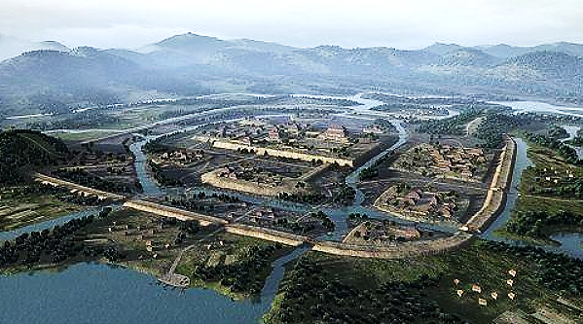

**Fig. 9. Liangzhu (300 ha)** showing the Dong Tiaoxi River in the background, the packed earthen perimeter walls, canals, elevated residences and the central, packed-earthen, rectangular Mojiaoshan (莫 角 山) communal center after an artist’s conceptualization **from** [**http://p3.pstatp.com/large/615f00050b7a0d5bc064**](http://p3.pstatp.com/large/615f00050b7a0d5bc064).



Fig. 10. **Liangzhu (300 ha) model** showing the canals from the Dong Tiaoxi River, the packed earthen perimeter walls, subsidiary canals, elevated residences and the upper central, rammed-earthen, rectangular Mojiaoshan (莫 角 山) 3 ha, 10 m-high, communal center. In addition, smaller, rammed-earthen platforms abound, some of which were constructed of fired adobe bricks. After an artist’s model **from** <http://p3.pstatp.com/large/616100014bf6036976ba>.



Fig. 11. Liangzhu complex on the Dong Tiaoxi River with water courses and subsidiary sites after https://www.degruyter.com

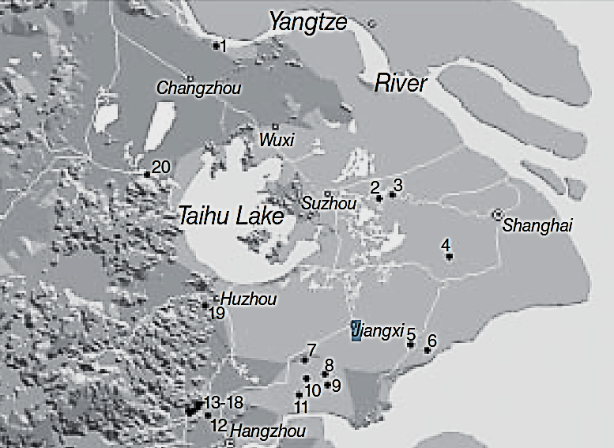

Fig. 12. Detail of major Middle Liangzhu Period associated sites. After Zhou Ying 2007.

1, Gaochengdun 高 城 墩; 2, Zhaolingshan 赵 陵 山; 3, Shaoqingshan 少 卿 山; 4, Guangfulin 广 富 林; 5, Pingqiudun 平 丘 墩; 6, Daimudun 戴 母 墩; 7, Xindili 新 地 里; 8, Pu’ anqiao 普 安 桥; 9, Zhangjiabang, 赵 家 浜, Xujiabang 徐 家 浜; 10, Heyedi 荷 叶 地; 11, Xubuqiao 徐 步 桥; 12, Miaoqian 庙 前; 13–18, Yaoshan 瑶 山, Fanshan 反 山, Huiguanshan 汇 观 山, Boyishan 钵 衣 山, Shangkoushan 上 口 山, Mojiaoshan 莫 角 山; 19, Yangjiabu 杨 家 埠; 20, Yannan 堰 南.

**GPS coordinates: ca** N 30°24', E 120°

**Cultural Affiliation**: Liangzhu culture, lower Yangtze River delta, 3300-2250 BCE

**Medium:** Jade

**Dimensions:** H 2.12 in, 53.79 mm; L 3.6 in, 91.34 mm

**Weight:**

**Condition:** original

**Provenance:** Yuhang County, Zhejiang Province

**Discussion:**

The bas-relief, engraved Taotie motif (a bi-laterally symmetrical animal mask) surmounted by a bas-relief, engraved shaman with a feather headdress, who has mastery, literally, over his animal spirit below. This iconography undoubtedly has its origins in the Paleolithic Period when shamanic imagery characterized the symbolism of hunter-gatherers who depended on wild boars and other animals for part of their sustenance (see Biot 1851).

Accordingly, animal taotie imagery was also pecked and inscribed as wild boar animal mask petroglyphs.

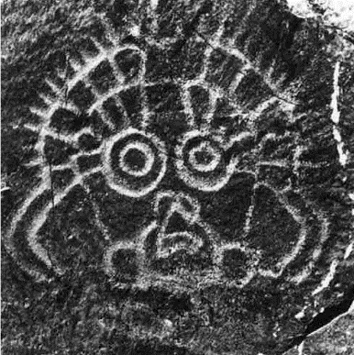

Fig. 13. Petroglyph of wild boar animal mask from Ningxia, China, after https://www.researchgate.net/figure/Face-like-motif-at-the-Helankou-site-Helan-Shan-Ningxia

By 3000-2600 BCE during the Mid-Liangzhu Phase, Liangzhu culture achieved a pinnacle of early cultural, engineering and economic development in a city with a size of about 300 ha that involved exquisite jade artistry, hydraulic planning and commerce. A suite of expertly designed and manufactured jade objects in élite burials provide a glimpse of the élite artisans who conceptualized and executed mythological, religious and ideological symbols into jade artifacts. This symbolism had evolved from a hunter-gatherer shamanic background into an animal husbandry of domesticated wild boars, that played an important economic and symbolic rôle in the development of Liangzhu culture. The ritual center of Mojiaoshan reflects a social cohesion that also enabled the organization of large-scale, collective, hydraulic engineering endeavors, including the construction of reservoirs, levees, dams, and canals that facilitated improved transportation and rice agriculture (Liu 2017).

Archaeological artifacts from the Mid-Liangzhu Phase (3000–2600 BCE) mostly came from the following sites (Fanshan, Gaochengdun 高 城 墩, Nanjing and Jiangyin 2009, Yaoshan, Zhaolingshan burial M77, Shaoqingshan 少 卿 山, Suzhou Museum 1988, and Guangfulin 广 富 林, Shanghai Archaeology 2008). However, the provenance of the current artifact is uncertain and so is given with the GPS coordinates of the original Liangzhu site.

DNA from Liangzhu culture sites around Taihu Lake exhibit high frequencies of Haplogroup O1 which was absent in other archaeological sites that were sampled inland of the Liangzhu Complex. Haplogroup O1 is common to modern Austronesians and Taiwanese Austronesians (TAN) (Li *et al*. 2007). O1 probably came from those Liangzhu Austronesians (LAN) who had been displaced from the mouth of the Yangtze River delta by an economic crash of the LAN ca 4500 BCE possibly induced by a meteor that struck at the present location of Taihu Lake, a meteoric crater (Erkang *et al*. 2002). Recent studies show that special micro-fractures in quartzite were formed during the unloading process after the compression at the peak of an impact event (Wang, Wan, Xu 2002). Bayesian phylogenetic analysis allows us to reconstruct a history of early Austronesians arriving in Taiwan in the north ~4,000 BCE, spreading rapidly to the south due to this catastrophic event (Ko *et al*. 2014).

The LAN culture that had been devastated by natural catastrophe ca 4200 BCE finally rehabilitated their farming in the vicinity of Taihu Lake by 3400 BCE at the beginning of the Early LAN Period.

Then, a series of catastrophic floods were created by diversions of the Yangtze River and other rivers in the Lake Taihu area ca 2100 BCE. These devastations are discernable by the way mud and sand intruded into the cultural layers of Late LAN Period sites. Perhaps spurred on by these floods, a second wave of LAN (ca 2000 BCE) emigrated south along mainland Southeast Asia to Vietnam and Cambodia (Tryon 1995). There some emigrated to southern Taiwan (Ko et al. 2014). From Taiwan the picture is less clear but those continuing to venture eastward found their way along the north coast of New Guinea, and then on to New Britain and New Ireland (Spriggs 1997), where both Austronesian languages and the Lapita culture left its trace. Austronesian speakers finally reached Bougainville ca 2950 (Spriggs).

Other trajectories of TAN migrants migrated north to Luzon in the Philippines (Hung 2005 a,b) and west to Madagascar.

**References:**

Biot, Jean Baptiste. 1851. *Le Tcheou-li: ou, Rites des Tcheou.* Paris: Imprimerie nationale, 1851. 3v.

Chang, K.C., Xu, P. and Lu, L. 2005. *The formation of Chinese civilization: an archaeological perspective*. New Haven: Yale University Press.

Childs-Johnson, Elizabeth. 1988. *Ritual and Power: Jades of Ancient China*. New York: China House Gallery, China Institute in America.

Childs-Johnson, Elizabeth. 2009. “The Art of working Jade and the rise of civilization in China.” In Elizabeth Childs-Johnson, *Early Chinese jades in American Museums*. Beijing: The Science Press, China Science and Technology Publishing and Media Co., Ltd., 2009, pp. 291-393.

Erkang, Wang, Yuqiu Wan, Shijin Xu. 2002. “Discovery and implication of shock metamorphic unloading microfractures in Devonian bedrock of Taihu Lake,” *Science in China Series D: Earth Sciences*, 45 (5): 459–467.

Gu Fang. 2005. *Complete collection of unearthed jades in China*. 15 v. Beijing: China Science and Technology Publishing and Media Co., Ltd.

Hayashi, Minao. http://lms01.harvard.edu:80/exlibris/aleph/u20_1/alephe/www_f_eng/icon/f-separator.gif林巳奈夫. 1991. Chūgoku kogyoku no kenkyū. http://lms01.harvard.edu:80/exlibris/aleph/u20_1/alephe/www_f_eng/icon/f-separator.gif中國古玉の研究. Tōkyō: Yoshikawa Kōbunkan; 東京: 吉川弘文館, 1991.

Hayashi, Mineo. 林巳奈夫. 1990. “On the Chinese Neolithic jade Tsung/Cong,” *Artibus Asiae*, 50(1/2):5-22.

Hayashi, Mineo. 林巳奈夫.1973.  *Toyo Gakuho* [*Journal of the Research Dept. of the Toyo Bunko*] 45:1-57.

Hung, Hsiao-Chun. 2005a. The culture interaction between Taiwan and adjacent islands—the origins and dispersal of Austronesian-speaking peoples, in *The Archaeology of Southeast Coastal Islands of China Conference*: 249–269, ed. Jonas Chung-yu Chen and Jian-Guo Pan. Taiwan: Mazu County Government (in Chinese).

Hung, Hsiao-Chun. 2005b. Neolithic interaction between Taiwan and northern Luzon. Journal of *Austronesian Studies* 1(1): 108–133.

Ko, A.M.S., Chen, C.Y., Fu, Q., Delfin, F., Li, M., Chiu, H.L., Stoneking, M. and Ko, Y.C., 2014. “Early Austronesians: into and out of Taiwan,” *The American Journal of Human Genetics*, *94*(3): 426-436.

Laufer, Berthold. 1912. *Jade: a study in Chinese archaeology and religion.* Field Museum of Natural History, Publication 154, Anthropological series, vol. X. Chicago.

Li, Hui; Huang, Ying; Mustavich, Laura F.; Zhang, Fan; Tan, Jing-Ze; Wang, Ling; Qian, Ji; Gao, Meng-He; Jin, Li. 2007. "Y chromosomes of prehistoric people along the Yangtze River," *Human Genetics* 122: 383–388.

Liu, Bin, Ningyuan Wang, Minghui Chen, Xiaohong Wu (吴小红), Duowen Mo, Jianguo Liu, Shijin Xu, and Yiji Zhuang. 2017. Earliest hydraulic enterprise in China, 5,100 years ago. *Proc*

*Natl Acad Sci USA* 114:13637–13642.

Regan, A.J. and Griffin, H.M., 2016. *Bougainville before the conflict*. Canberra: ANU Press.

Tryon, Darell. 2016. “The Languages of Bougainville.” In Regan, A.J. and Griffin, H.M., *Bougainville before the conflict*. Canberra: ANU Press, pp. 31-46.

Wenbao, Lu. 1998. “Cong-shaped bead.” In Liangzhu Culture Museum, ed., *The dawn of Chinese civilization: Jades of the Liangzhu culture.* Hong Kong: Liangzhu Culture Museum and The Art Museum, The Chinese University of Hong Kong.

Wu, Li. 2014. "Holocene environmental change and its impacts on human settlement in the Shanghai Area, East China," *Catena* 114: 78–89

Zhejiang [ 浙 江 省 文 物 考 古 研 究 所]. 2003. 瑶 山 (*Yaoshan Site*). Beijing: Wenwu.

Zhejiang [ 浙 江 省 文 物 考 古 研 究 所]. 2005a. 反 山 (*Fanshan Site*). Beijing: Wenwu.

Zhejiang [ 浙 江 省 文 物 考 古 研 究 所]. 2005b. 良 渚 遗 址 群 (*Liangzhu Site Group*). Beijing: Wenwu.

Zhejiang [ 浙 江 省 文 物 考 古 研 究 所]. 2008. 杭 州 市 余 杭 区 良 渚 古 城 遗 址 2006–2007 年 的 发 掘 (Excavation of the Liangzhu Ancient City Site 2006–2007 at Yuhang of Hangzhou). *Kaogu* 2008 (7): 3 – 10.

Zhang, Chia; Hsiao-Chun, Hung. 2008. "The Neolithic of Southern China–Origin, Development, and Dispersal," *Asian Perspectives*. 47:2, 309–310.

|  |
| --- |
| Zhou Ying. 2007. 东方文明的曙光: 良渚遗址与良渚文化 = Dong fang wen ming de shu guang: Liang zhu yi zhi yu liang zhu wen hua = *The Dawn of the Oriental Civilization: Liangzhu site and Liangzhu culture.* Beijing: China Intercontinental Press. |